CSPC 310 Homework 1

Raymond Zhu

923008555

1.

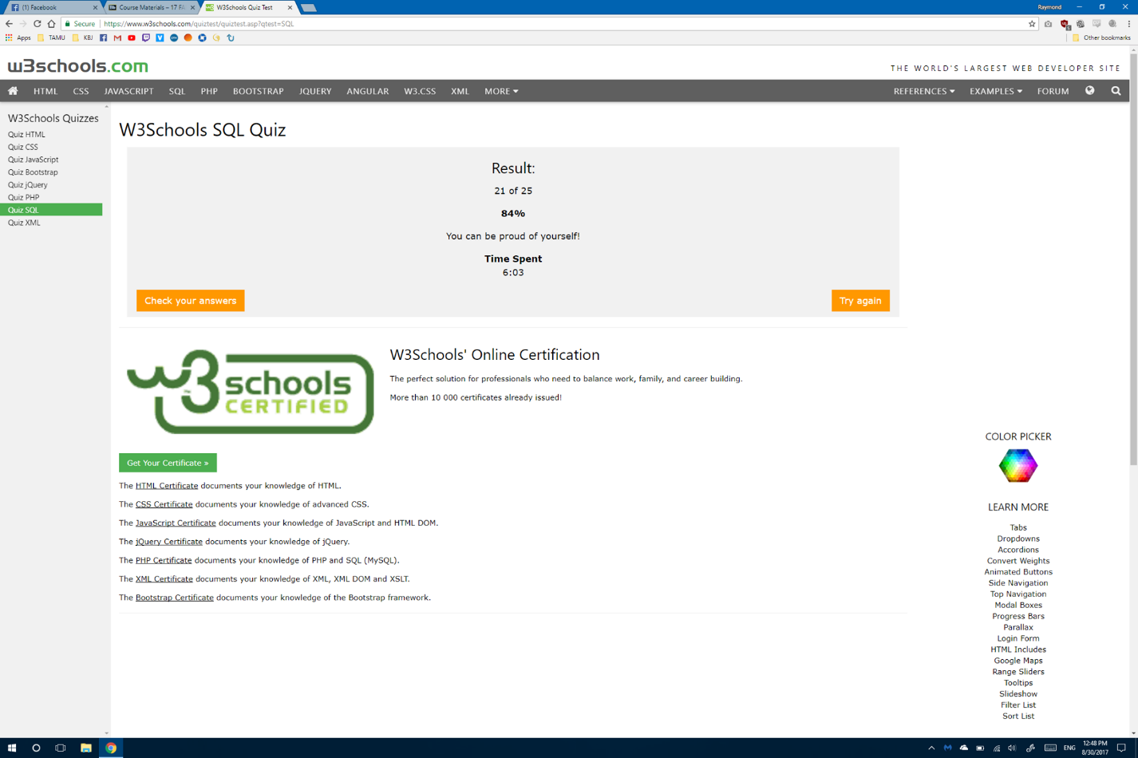

2.

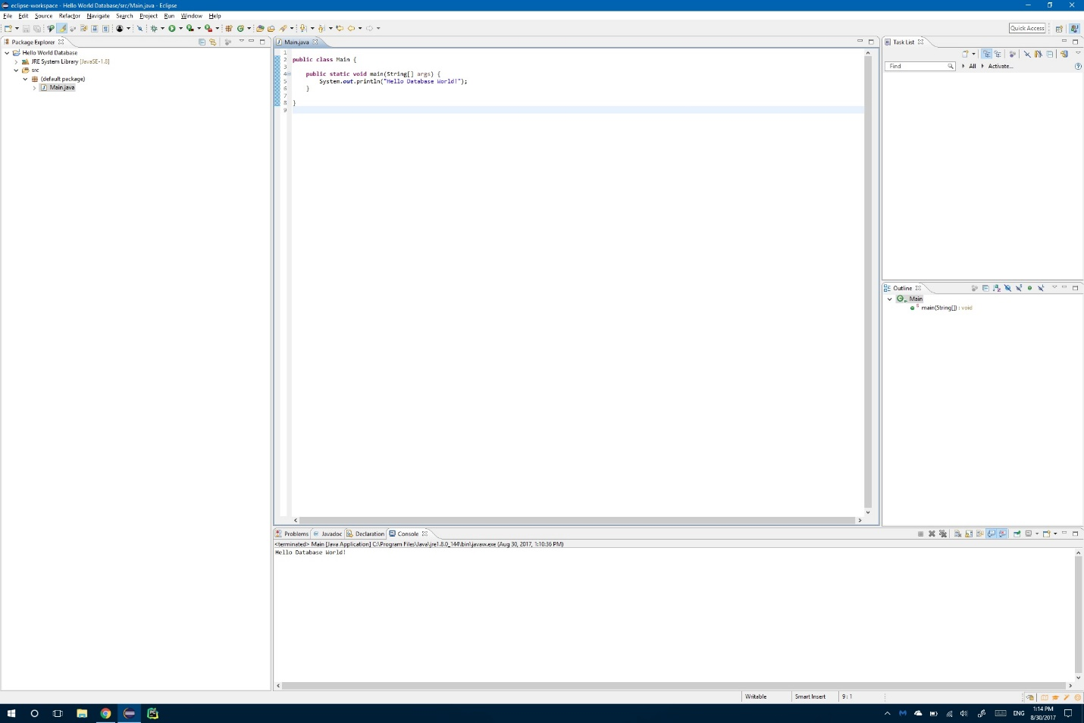

3a.

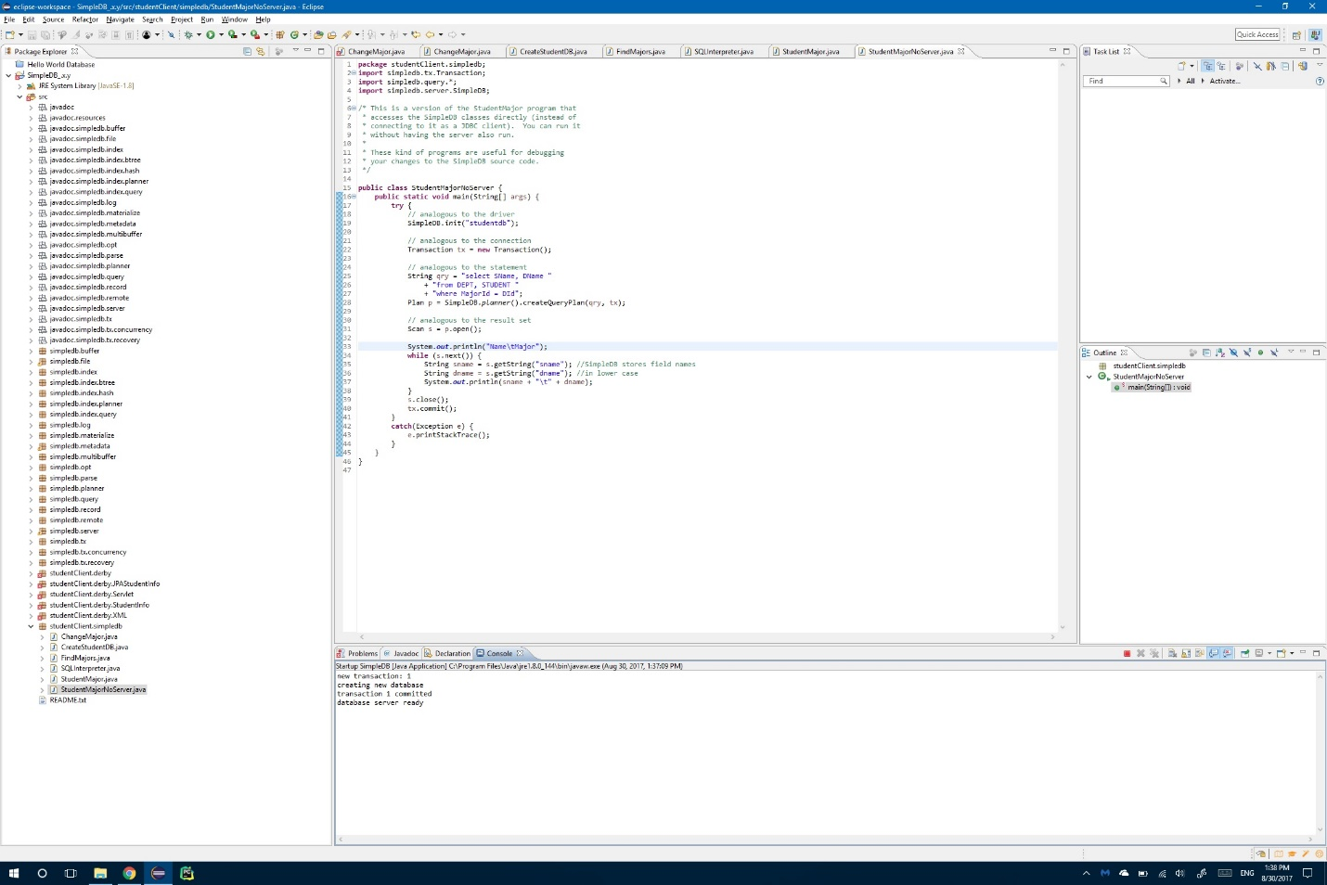

The red rectangle means that the server is running. Clicking on it would terminate the local server

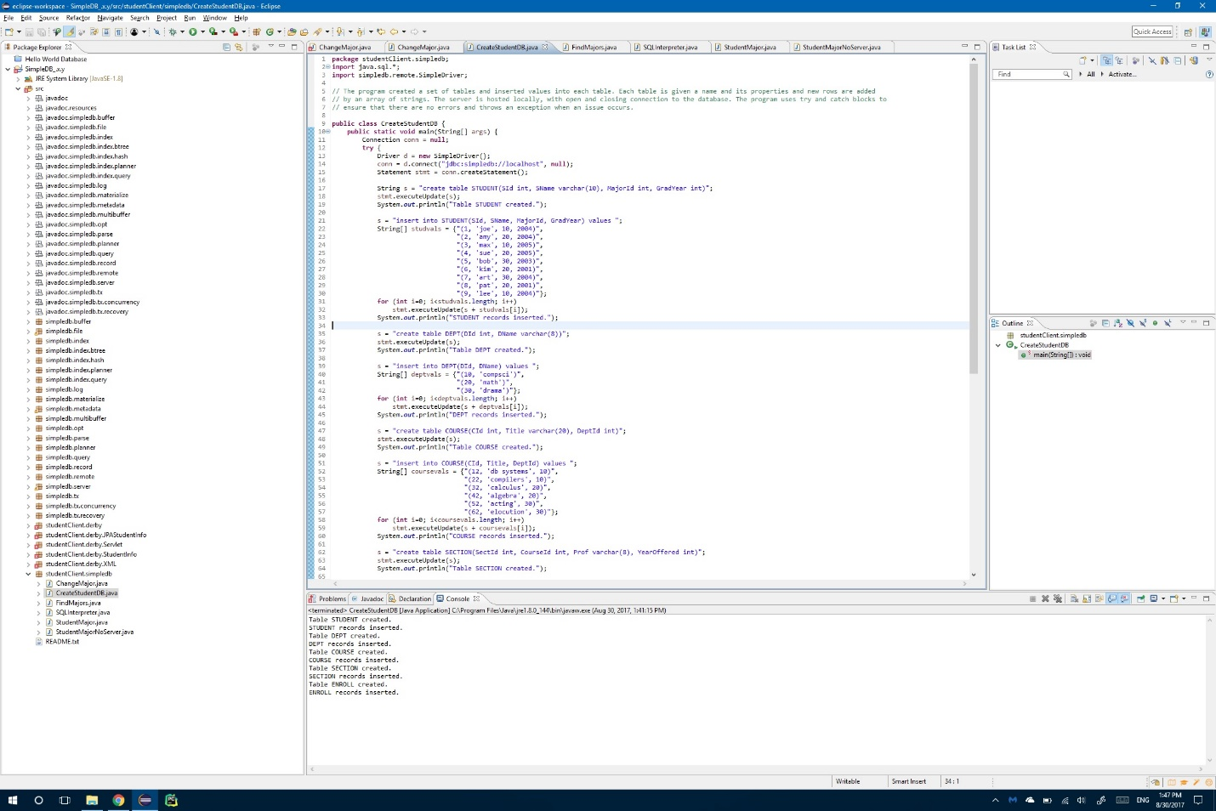3b.

The program created a set of tables and inserted values into each table. Each table is given a name and its properties and new rows are added by an array of strings. The server is hosted locally, with open and closing connection to the database. The program uses try and catch blocks to ensure that there are no errors and throws an exception when an issue occurs.

3c.

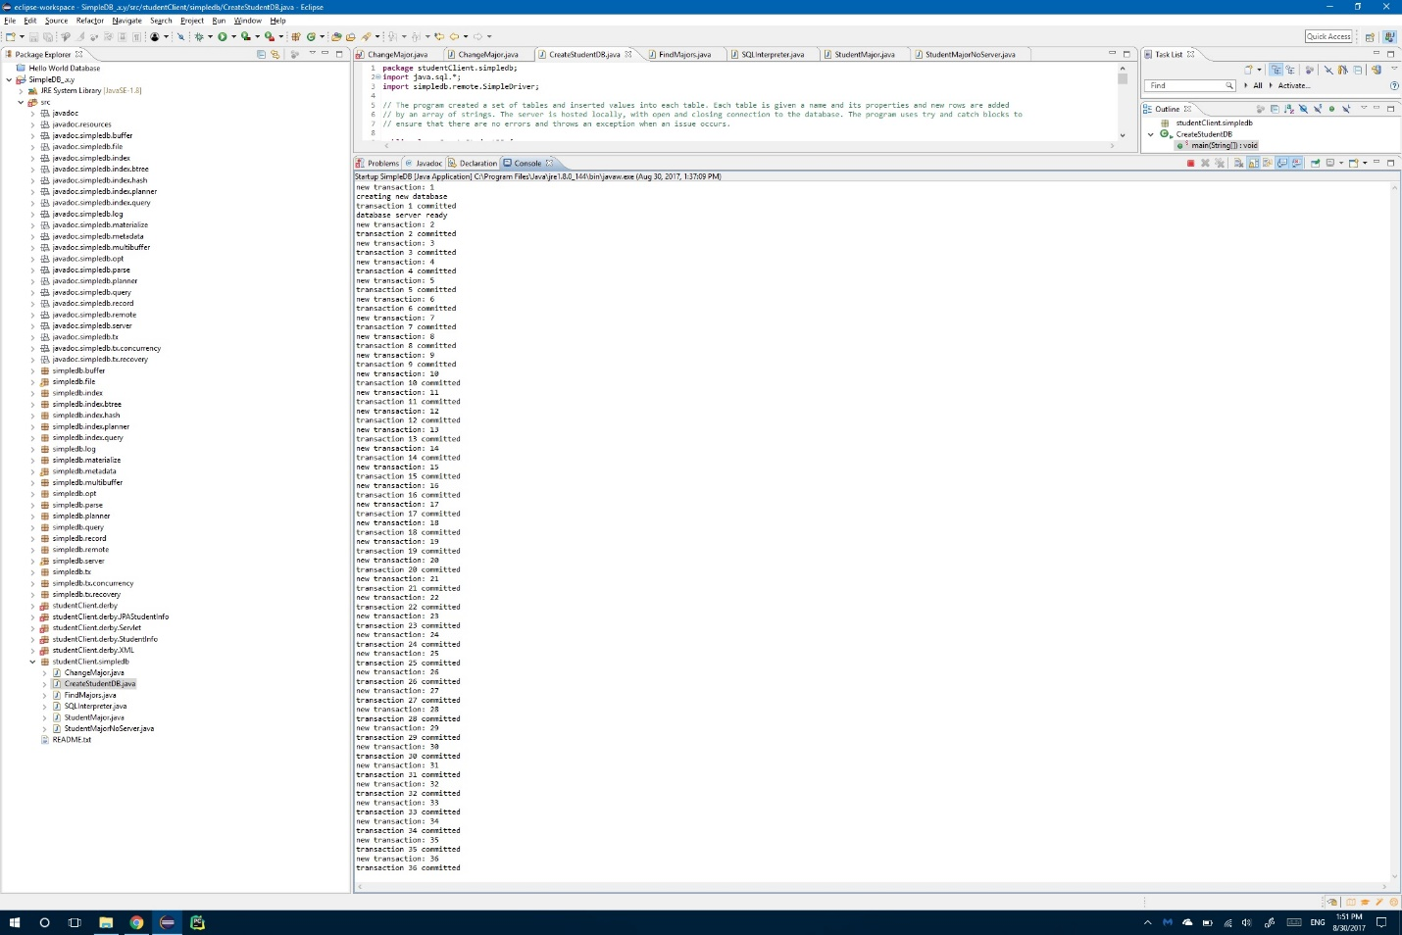

The red rectangle is still present in the server console window because the server is still active and listening for commands.

3d.

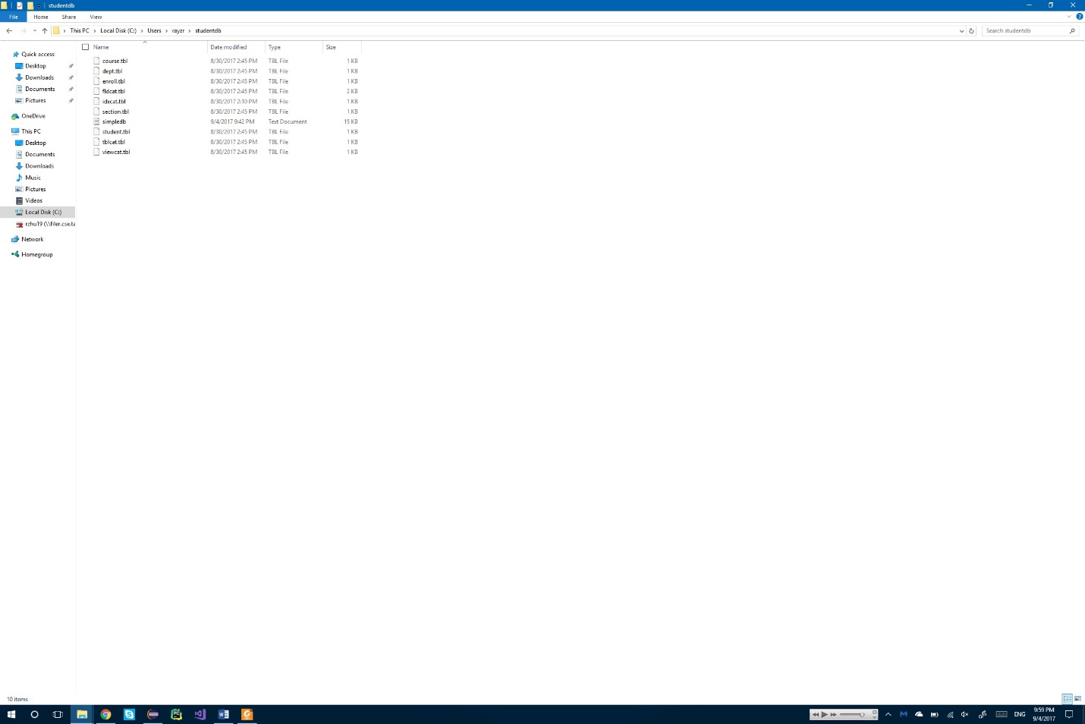

The startup app actually creates the folder studentdb. It can be found under simpleDb’s init() method. CreateStudentDB is responsible for the naming of the tables while simpleDB is responsible for creating the files.

4.

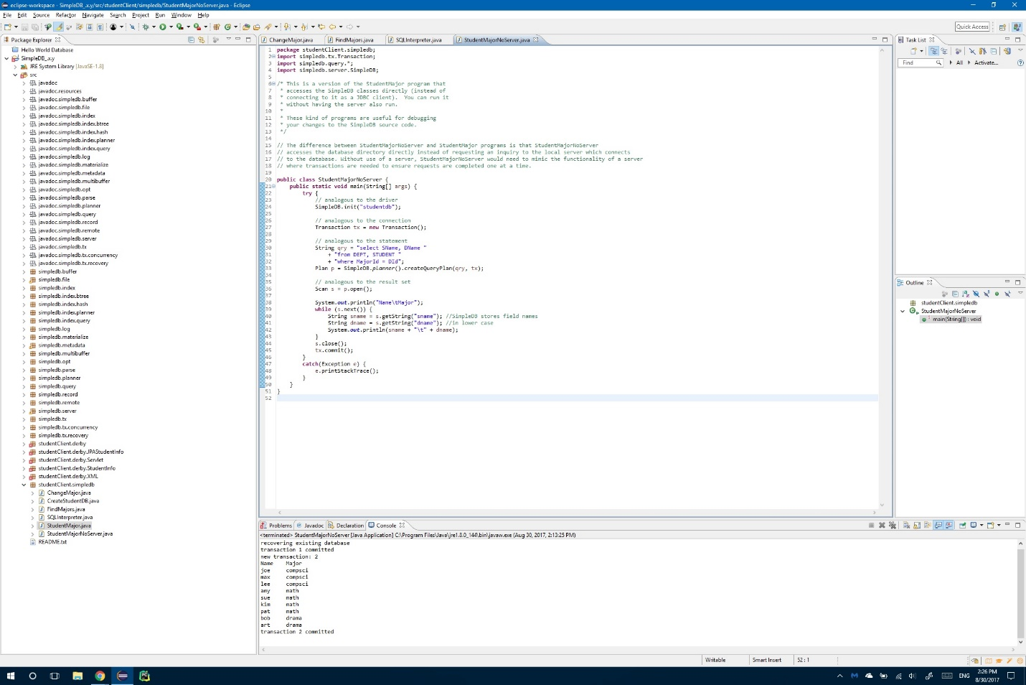

The difference between StudentMajorNoServer and StudentMajor programs is that StudentMajorNoServer accesses the database directory directly instead of requesting an inquiry to the local server which connects to the database while StudentMajor connects via JDBC to the simpleDB in our localhost. The application and StudentMajorNoServer are mingled together because StudentMajorNoServers calls the simpleDB init() method granting direct access to the server where transactions are needed to ensure requests are completed one at a time. And so loading the previous data table and selecting from the table needs to be executed atomically and in isolation with one another.

5.

Time:

To describe time we can look at the speed of cpus where the baseline of 1 Ghz represents 1 second in human time.

1 Mhz = 16.7 minutes

1 khz = 11.6 days

1 hz = 31.7 years

Latency:

To describe latency we can look at downloading a file where the baseline is downloading a 1 kb file every second.

One order of magnitude higher is downloading a file size of 1 mb every second.

Two orders of magnitude higher is downloading a file size of 1 gb every second.

Three orders of magnitude higher is downloading a file size of 1 tb every second.

Throughput:

To describe throughput we can look at a highway ramp where the baseline is one vehicle getting through every second.

One order of magnitude higher is at noon where many vehicles are getting on and off the highway every second.

Two orders of magnitude higher is during rush hour where hundred of vehicles line up to get on the ramp every second.

Three orders of magnitude higher is when an accident occurs during rush hour slowing vehicles entering the ramp every second.

An Aggie does not lie, cheat, steal, or tolerate those who do.